Simulation of Inductive Power Transfer Systems Exposing a Human Body with Two-Step Scaled-Frequency FDTD Methods

Martin Zang1, Markus Clemens1, Carsten Cimala1, Joachim Streckert1, and Benedikt Schmuelling2

1Chair of Electromagnetic Theory, University of Wuppertal, 42119 Wuppertal, Germany

2E-Mobility Research Group, University of Wuppertal, 42119 Wuppertal, Germany

For the simulation of the human exposure to magneto-quasistatic fields of inductive power transfer (IPT) systems two domain decomposition methods – the Coupled Scaled-Frequency FDTD method and the Co-Simulation Scaled-Frequency FDTD method – are presented in this paper. Using both Huygens’ principle and the Scaled-Frequency FDTD method, a two-step approach is developed resulting in two different simulation schemes, the Coupled Scaled Frequency FDTD method and the Co-Simulation Scaled Frequency FDTD method, respectively. These two-step schemes are able to replace high-dimensional monolithic exposure simulation models by problems of smaller size with less computer memory demand. An exposure scenario including an IPT system, a car and a high-resolution human body voxel model is modelled and simulated using both methods. A full-scale monolithic Scaled-Frequency FDTD simulation is used as reference and its results – i.e., the body-internal electric field strengths – are compared to the results of the presented two-step methods. The maximum of the body-internal electric field strength (voxel average) is determined and compared to basic restrictions given by the International Commission on Non-Ionizing Radiation Protection (ICNIRP).

*Index Terms*—Domain decomposition, frequency scaling, Huygens’ principle, human exposure.

# I. Introduction

I

nductive power transfer (IPT) systems are used to charge batteries of electric or hybrid electric vehicles. These systems include an induction coil which is driven by an alternating current with frequencies of 80 up to 140 kHz enabling a power transfer of up to 20 kW. Alternating currents generate magneto-quasistatic fields which a human body –positioned in the IPT system’s surrounding – can be exposed to. In the event of a human exposure, the exposing field changes the natural body-internal distribution of the electric field strength which might cause stimuli of nerve and muscle tissue. To prevent this, the International Commission on Non-Ionizing Radiation Protection (ICNIRP) recommends limits for the body-internal electric field strength [1].

Electromagnetic simulations of such scenarios contain numerical challenges due to the involved low frequencies of the charging processes in addition to very complex conductive material distributions: both the car body sheets and the human body voxel model require grid resolutions in the millimeter range within 3D exposure scenarios with several meters of range. In addition, the electric conductivity values of the metallic car parts and the body tissues vary by up to eight orders of magnitude. For such problems the use of conventional magneto-quasistatic field solvers requires the solution of a high-dimensional and very ill-conditioned algebraic system of equations.

Alternatively, numerical schemes are in use that rely on the negligible interaction of the exposed organic tissue on the exterior low frequency magnetic fields. Within numerical schemes such as the Scalar Potential Finite Difference (SPFD) method [2] the electric field calculation inside the IPT magnetic field exposed human body models requires the solution of a large-scale discrete Poisson equation with O(107) degrees of freedom. The Co-Simulation SPFD method [3] is a variant method extended to include shielding effects of the car body sheets and other shielding materials of finite (metallic) electrical conductivity.

Another simulation approach relies on the use of high-resolution Scaled Frequency Finite Difference Time Domain (SF-FDTD) schemes [4],[5] for these IPT low-frequency 3D magnetic field exposure scenarios [3]. This approach allows to use extremely high resolutions within commercial FDTD implementations, but may require large computational resources. To overcome this problem, two two-step domain decomposition techniques are introduced that allow to use the SF-FDTD method for the calculation of the induced body-internal electric fields.

The paper is organized as follows: in the Section II following this introduction the main ideas of the Scaled Frequency FDTD approach are presented. The Section III introduces the corresponding two-step domain decomposition schemes dubbed the Coupled Scaled-Frequency FDTD and Co-Simulation Scaled-Frequency FDTD method, respectively. In Section IV a numerical IPT exposure simulation is presented featuring these three numerical high-resolution dosimetry methods, followed by a discussion of the results and by a conclusion.

# II. The Scaled-Frequency FDTD Method

The Scaled-Frequency FDTD method is a method for the simulation of low-frequency magnetic field exposure scenarios [4], [5]. In this method, the standard FDTD method that is originally designed for high-frequency electromagnetic fields is used to simulate the magnetic field exposure problem at a higher frequency  than the original (low) frequency of interest . The results – i.e., the body-internal electric field strength  – are scaled down to frequency  afterwards according to the correlation

|  |  |  |
| --- | --- | --- |
|  | , | (1) |

where  is the electrical conductivity of the body tissues. The shielding properties of metallic or carbon-fiber material car body sheets (represented by the values of their skin depth ) vary with frequency. As a consequence, within SF-FDTD schemes the conductivities of such shielding materials also need to be scaled such that

|  |  |  |
| --- | --- | --- |
|  |  | (2) |

holds, which means that the conductivity of the body sheets needs to be scaled according to the proportionality ~.

# III. Two-Step Scaled-Frequency FDTD Methods

The two-step Scaled-Frequency FDTD methods rely on a domain decomposition approach where the Huygens’ principle [7], [8] is used to divide a large-scale magneto-quasistatic exposure scenario into two calculation domains of smaller size (compared to a monolithic simulation). In a first step the electromagnetic source field is simulated without a human body voxel model w.r.t. the negligible interaction of body-internal eddy currents with the exterior magnetic field. The resulting source field solution is used to derive a current distribution on a closed surface *F* around the human body voxel model. In a second step, only within this region around the exposed body a high-resolution SF-FDTD scheme is used. Depending on which quantities are used as equivalent sources, on this surface two schemes can be derived.

## A. Coupled Scaled-Frequency FDTD Method

Assuming that the external source field is calculated with a SF-FDTD method in the first step, the equivalent Huygens’ sources on the surface *F* around the body consist of an electric current density

|  |  |  |
| --- | --- | --- |
|  |  | (3) |

and a magnetic current density

|  |  |  |
| --- | --- | --- |
|  | , | (4) |

where  is the normal of *F*, and the field quantities****** and  are the tangential components of the electric and magnetic field strength on *F*.

Figure 1 shows an example of an exposure scenario including a current driven coil and a human body voxel model. The electromagnetic source field is simulated and the tangential components of the electric and magnetic field strengths are imprinted on the surface *F* of a cuboid which is dubbed the Huygens’ box comprising the designated position of the human body voxel model (Figure 1 a)). Figure 1 b) shows the source distribution on *F*, where now the human body voxel model is positioned inside the Huygens’ box.

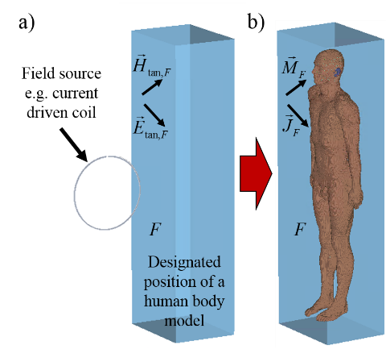

Fig. 1. a) Current driven coil with empty target area and imprinted tangential electric and magnetic field strengths on surface *F* surrounding the target area b) Imprinted electric and magnetic current densities on closed surface *F* surrounding the human body model

## B. Co-Simulation Scaled-Frequency FDTD Method

In some cases it might be advantageous to calculate magnetic shielding properties of high conductivity (or even ferromagnetic) materials using a specialized magnetic field simulation tool. Then the problem arises, however, that many commercial eddy current solvers only deliver magnetic field distributions as a simulation result. In this case, only the electric current densities can be derived from the source field as an equivalent source for the SC-FDTD method inside the Huygens box around the body under exposure. To overcome this problem, the outer region of the closed surface *F* is replaced with a perfect magnetic conductor () which can be numerically approximated by magnetic boundary conditions () with SF-FDTD schemes. As a consequence, the magnetic current densities  are neglected and forced to be zero and only the electric current densities  derived in (3) are the equivalent sources to generate an electromagnetic field distribution in the Huygens’ box (Figure 2 b)). The resulting Co-Simulation Scaled-Frequency FDTD method corresponds to a monolithic field solution, but without the complexity of a direct source simulation.

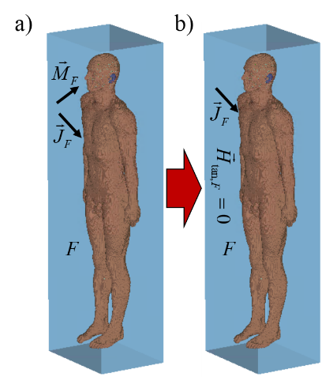

Fig. 2. a) Imprinted electric and magnetic current densities on closed surface *F* surrounding the human body model representing the outer region (source)

b) Assignment of magnetic boundary conditions to surface *F* corresponding to a neglect of the magnetic current densities

# IV. Numerical Example

As a numerical example an exposure scenario is shown here consisting of an IPT system, a model of a car and a human body voxel model. The IPT system is positioned below the car and the human body model is standing beside the car (Figure 3).

The IPT systems consists of two coils - the induction (primary) coil and the pickup (secondary) coil - which are both modeled as perfectly electric conducting (PEC) loops. The wires have a radius of 1 mm and the loops have a radius of 249 mm. The induction coil is driven by an alternating current of 144 A (peak) at 140 kHz. Both coils are coupled via

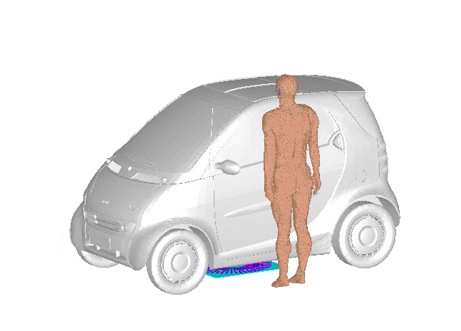

Fig. 3. Inductive power transfer (IPT) system positioned below a car model and a human body voxel model standing beside the car

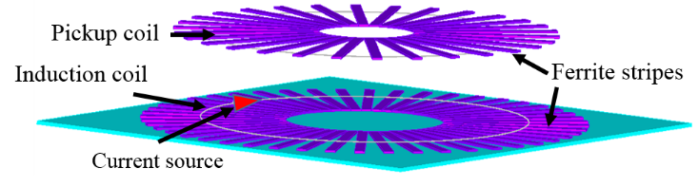

Fig. 4. Arrangement of the coils, ferrite stripes (purple) and the shielding plate (blue) in the IPT system and position of the current source driving the induction coil

an airgap of 129 mm. Ferrite stripes (purple, µr = 2000) are positioned below the primary coil and above the secondary coil, respectively. An aluminum shielding plate (blue) with a conductivity of 3.7∙107 S/m is positioned below the induction coil. The arrangement of the entire IPT system can be seen in Figure 4.

The car body consists of thin carbon sheets with an electric conductivity of ** = 7,000 S/m.

The human body voxel model (“Duke” from the Virtual Family [9]) has a resolution of 2 mm (edge length of the voxel cells) and consists of 77 different biological tissues.

The Coupled Scaled-Frequency FDTD method and the Co-Simulation Scaled-Frequency FDTD method are both applied to simulate the exposure of the human body voxel model to the magneto-quasistatic field generated by the IPT system including the shielding effects of the car body sheets. At first, the source field simulation (IPT system and car model) is performed at a frequency of 2 MHz using CST Microwave Studio (MWS) [6]. The calculation domain is discretized with about 324 mio. mesh cells. Figure 5 shows the distribution of the magnetic field strength in a cross section of the car model. The designated position of the body voxel model and the Huygens’ box are indicated in the field plot.

In the next step, the source field results are taken to derive the distributions of the tangential electric and magnetic field strengths – and thus the current density distributions – on the Huygens’ box, which is shown in Figure 6. The electromagnetic field distribution is calculated inside the Huygens’ box and the human body voxel model, respectively, performing two simulations. In the first simulation the exposure field is generated by both the electric and the magnetic current densities (see Figure 1 b). The calculation domain is terminated by open boundary conditions (located in a distance of 30 cm from the Huygens’ box) and consists of about 74 mio. mesh cells.

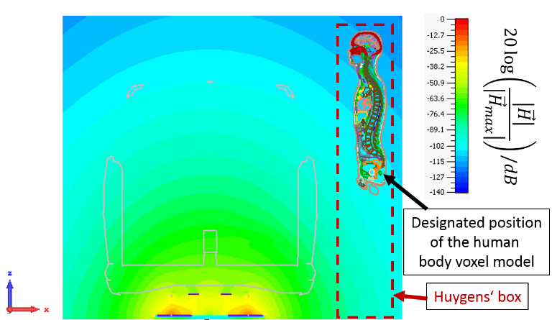

Fig. 5. Magnetic field strength generated by the IPT system in a cross section of the car model with the designated positions of the human body voxel model and the Huygens’ box indicated in the field plot

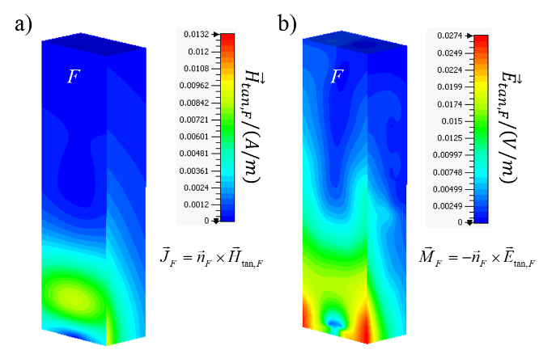

Fig. 6. Distributions of a) the tangential magnetic and b) the tangential electric field strengths on the surface of the Huygens’ box

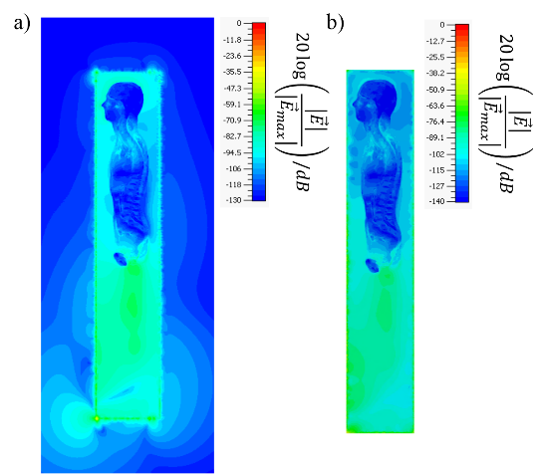

Fig. 7. Distributions of the electric field strength in the median plane of the human body voxel model simulated with a) the Coupled Scaled-Frequency FDTD method and b) the Co-Simulation Scaled-Frequency FDTD method

In the second simulation only the electric current densities are considered and the magnetic current densities are replaced by magnetic boundary conditions (, according to Figure 2 b)). Here, the calculation domain is discretized with about 43 mio. FDTD mesh cells. After calculating the electromagnetic field inside the Huygens’ box the electric field solution is scaled down to the original frequency of interest 140 kHz according to (3). Figure 7 shows the results for both simulations in terms of the distributions of the electric field strength in the median plane of the human body voxel model.

The determination of the voxel-averaged body-internal electric field strengths yields a maximum value of 0.683 V/m which is about 3.4% of the basic restrictions for general public exposure (1.7% for occupational exposure) given by ICNIRP.

## A. Memory Requirements

In Table I the computational memory requirements are listed. The monolithic SF-FDTD simulation requires a high-performance computer, which is performed for this test problem on a multi-GPU cluster with 25 NVIDIA Tesla K20m GPUs and 10 Intel Xeon E5 CPU processors. For both two-step SF-FDTD methods the memory demands reduce to about one third of the monolithic SF-FDTD simulation. Simplifying the complexity of the shielding geometries in the source field simulation, i.e., the car body sheets, should enable to further reduce the memory demands of the two-step Scaled-Frequency FDTD methods such that simulations can be run on standard computer workstations.

TABLE I

Memory Requirements For the Numerical Simulations

|  |  |  |
| --- | --- | --- |
| **Monolithic Scaled-Frequency FDTD simulation with CST MWS** | **Coupled Scaled-Frequency FDTD** | **Co-Simulation Scaled-Frequency FDTD** |
| **~ 356 GB** | Source field simulation:  **~ 129 GB** | |
| Exposure simulation:  **~ 37.5 GB** | Exposure simulation:  ~ **24.3 GB** |

## B. Comparison of the Results

To validate the new two-step SF-FDTD methods, a monolithic SF-FDTD method is used for a simulation of the entire exposure scenario with about 906 mio. mesh cells. The resulting body-internal electric field strength () is compared to the solutions of the Coupled SF-FDTD method () and the Co-Simulation SF-FDTD method (). Figure 8 compares the relative error of both solutions to the reference solution. The relative errors of the maximum values of the electric field strength in the shown plane are smaller than 3%. Within Figure 8, in some areas of the body the relative error is much higher than the relative error of the maximum electric field values. Since these deviations occur in areas with very small electric field strengths and since only the maximum electric field strengths are important for the exposure assessment, these deviations are acceptable.

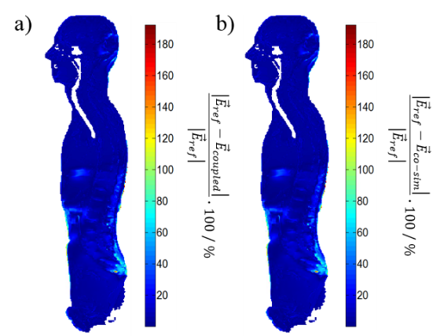

Fig. 8. Relative error of the body-internal electric field strength computed with a) the Coupled Scaled-Frequency FDTD method and b) the Co-Simulation Scaled-Frequency FDTD method compared to a reference solution of a monolithic Scaled-Frequency FDTD simulation

# V. Conclusion

Two domain decomposition methods for the simulation of the human exposure to magneto-quasistatic fields of inductive power transfer (IPT) systems, i.e., the Coupled Scaled-Frequency Finite Difference Time Domain method and the Co-Simulation Scaled-Frequency FDTD method, were presented. With these two-step methods smaller simulation domains and thus smaller memory requirements were achieved in comparison to monolithic SF-FDTD simulations. Both methods have shown results in good agreement with a reference solution of a monolithic SF-FDTD simulation.

Acknowledgement

This work is supported by the Deutsche Forschungs-gemeinschaft (DFG) under grant number CL143/14-1.

References

[1] ICNIRP – International Commission on Non-Ionizing Radiation Protection, “Guidelines for limiting exposure to time-varying electric and magnetic fields (1 Hz-100 kHz),” Health Physics, vol. 99, no. 6, pp. 818-836, 2010.

[2] T. W. Dawson, J. de Moerloose, and M. A. Stuchly, “Comparison of magnetically induced ELF fields in humans computed by FDTD and scalar potential FD codes,” *ACES J.*, vol. 11, pp. 63-71, 1996.

[3] C. Cimala, M. Zang M. Clemens, J. Feng, B. Schmuelling, and J. Streckert, "Numerical Schemes for High-Resolution Dosimetry Simulations of Automotive Low Frequency Inductive Power Transfer Systems," Proc. of the *ICEAA IEEE-APS 2015*, Torino, Italy, 07.-11.09.2015, pp. 1044 - 1047.

[4] O. P. Gandhi and J.-Y. Chen, "Numerical dosimetry at power-line frequencies using anatomically-based models," *BioEM Suppl. I*, pp. 43-60, 1992.

[5] W. T. Kaune and M. F. Gillis, „General properties of the interaction bet-ween animals and ELF electric fields,” *BioEM*, vol. 2, no. 1, pp. 1-11, 1981.

[6] CST AG, Bad Nauheimer Straße 19, 64289 Darmstadt, Germany.

[7] S. A. Schelkunoff, "Some equivalence theorems of electromagnetics and their application to radiation problems," *Bell System Tech. Journal*, vol. 15, no. 1, pp. 92-112, 1936.

[8] A. E. H. Love, “The integration of the equations of propagation of electric waves,” *Phil. Trans. Roy. Soc. Lond. A*, vol. 197, no. 287-299, pp. 1-45, 1901.

[9] A. Christ, W. Kainz, E. G. Hahn, et al., „The virtual family -development of surface-based anatomical models of two adults and two children for dosimetric simulations,” *Phys. Med. Biol.*, vol. 55, no. 2, pp. N23–N38, 2010.